SVTTA 15 TT SPEED FAMILY TROPHY

SUNDAY 26 SEPTEMBER 2021
8.00 AM START
COURSE – WM15/01

Headquarters: Cambusbarron Village Hall, Cambusbarron, Stirling FK7 9NU

PROMOTED BY: Scottish Veteran Time Trial Association
Under CTT
Rules and Regulations

Organiser: Mhairi Laffoley, 22 Frankfield Place, Dalgety Bay KY11 9LR
Tel: 01383 822349 or email: mhairilaffoley@gmail.com

Timekeepers – Start: Dave Bean Finish: Catriona Stirling Recorder: Gavin Laffoley

Event Headquarters Open from 7 AM

Race Program

COVID Regulations

Being aware of the welfare of the local community, and of the future cycling events, the S.V.T.T.A. in the knowledge that whilst some of the Covid Restrictions have been relaxed, the S.V.T.T.A will however, continue to implement social distancing for the current event and request that, when signing on/off within the Community Centre that you continue social distancing, wear a face mask and do not linger within the premises. The hall is not available for changing purposes but for signing on and off only, and for use of toilet facilities. Unfortunately, there will be no refreshments provided.

Parking:

Parking is available on-street or at the small car park at the HQ but again would ask that after signing off after the event that you do not linger longer than necessary.

Please note: Parking will not be allowed in the adjacent Bowling Club Car Park or in the housing estate behind the hall nor will there be parking at the event start or finish.

Start:

The start is on the A811 approximately ½ mile to the East of the Kersebonny Road end, Cambusbarron. It is approx. 1 ½ miles from the event HQ.

The start is accessed from Cambusbarron village by turning right from the HQ entrance, proceeding into the village, turning right down Mill Brae after about a quarter of a mile and left onto Mill Road, which leads to Kersebonny Road. Turn right at the end of the Kersebonny Road (please take extra care as you will be turning over the course/traffic and riders will already be underway) and head East towards Stirling Castle. Cross the motorway flyover and the start is approx. 320 m west of Clay Toll Roundabout.
Please DO NOT warm up on the course but note that you will need to cross through the finish line to make your way to the start. If you are on the way to your start DO NOT adopt a racing position as you go through the finish area to avoid confusion for the timekeeper and take care not to interfere with those racing.

Map of route from HQ to the A811
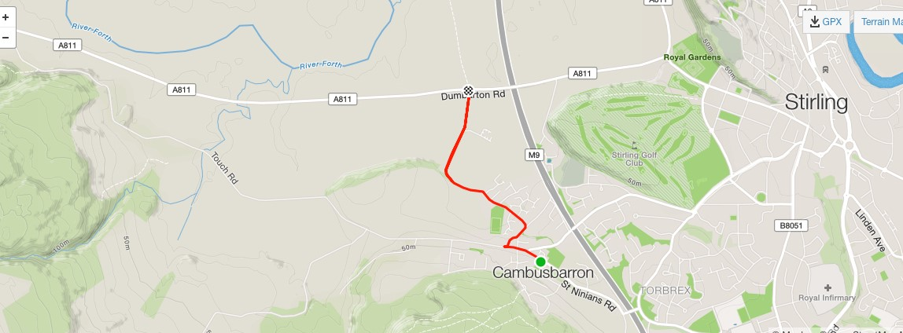
The course:

The course is an out and back along the A811. From the start it heads west to turn at the Kippen roundabout. There will be Marshals at this point. They are not allowed to stop traffic so riders must adhere to highway code when negotiating the roundabout. Retrace along the A811 crossing over the motorway flyover and finish at the entrance to Falleninch Farm. On your return to the HQ please be considerate whilst riding on A811 back to Kersebonny Road as there will be other riders who have just started their race.

Other Important Information:

- There will be limited space at start area; riders are requested to arrive no more than 5 mins before their start time but remember to give yourself sufficient time if riding from Cambusbarron.

- NO pusher off – All riders will be required to start with one foot on the ground.
- Start timekeeper will NOT be able to bring jackets etc back to HQ. No responsibility will be taken for any jackets or personal belongings left at the start.
- Riders MUST having a working rear light fitted to their bike.
NO light NO start.
- Riders should NOT stop at the finish area and should continue to HQ where they need to SIGN OUT. If you DO NOT sign out, you will be recorded as a DNF.
- There will be NO prize giving or reading of results after race (hopefully we can get back to normal next year). The result sheet will appear on the CTT website after approval. Prize winners will be notified by post.
- Please DO NOT ride with your head down. There are often slow-moving tractors, etc on this course and as exit from some of the bends you may come across them so please remain vigilant

The organiser extends her thanks to all the volunteers helping today, as without their participation the race would not be able to go ahead.

